**THE PLANT CELL IN A NUTSHELL – INSTRUCTIONS FOR AUTHORS**

The Nutshell will be published in blog form with title and image at <https://plantae.org/research/the-plant-cell/#in-a-nutshell>. The text alone, under the heading “In a Nutshell” will be published with the final version of the manuscript underneath the abstract online and on the top of page 2 of the typeset pdf, provided the form is returned before the science editor issues final acceptance on your manuscript.

Please answer the questions below, taking care to avoid technical jargon or field-specific language that would prevent someone from outside your field from understanding the results of your paper. The target should be college level, thinking more of the science enthusiast rather than the scientist. Answers to the four questions together should not exceed 350 words. *Please return the completed form at your earliest convenience (ideally within 3-5 days); we will also use answers to help determine which articles to highlight with a press release. You might also provide the nutshell summary and additional information to your own institution's press office as a press release or the basis of a press release.*

**Tips:**

-imagine you are explaining your work to a first-year undergraduate or even advanced high school student (if possible, you could even ask such a student to check your answers).

-use common words or phrases instead of technical words whenever possible (e.g. "new" instead of "novel"; "at the same time" rather than "simultaneously"),

-if you must use a specialist/technical term, define it first in more everyday language,

-only use acronyms that are well known (such as DNA) or absolutely essential (such as gene or protein names),

-use active sentences with verbs, and keep your answers short and to the point. All sentences should be shorter than 35 words and answers should stick to the suggested word limits.

**QUESTIONS (Answers to all four questions together may not exceed 350 words):**

**Background:** How would you introduce the background to your research to someone who is completely unfamiliar with your field? (Please make sure to provide simple definitions for ALL technical terms) (about 125 words).

**Question:** What exact question did you set out to answer? (Was this something that was previously unknown? Alternatively, did you want to test/build-upon previous findings?) (~ 50 word).

**Findings:** What is/are the most important finding of your paper? (Please mention which organism or cells you used - for example, wild-type and mutant Arabidopsis, rice, seedlings, field grown plants, cultured cells, etc) (~ 125 words).

**Next steps:** What is the most important next step or future challenge that follows from your work? (~ 50 words).

**ADDITIONAL INFORMATION**

**Title:** Suggest a short plain-language title for the summary. The editor will also help with title suggestions.

**Author(s) and Institutions:** Please list the name of the author or subset of authors who help to write the summary, along with their institutions.

**Twitter name:** provide any twitter names you would like us to tag when posting your blog (personal or for your lab or institution)

**Key words:** You may suggest up to 4 keywords associated with your article.

**Image:** Please select a feature image to accompany your blog. This should be a reasonably simple, colorful, descriptive, eye-catching image which may be a figure or panel of a figure from your paper, or it could be a photo of the species used in your work or a cartoon model or art work that represents some aspect of the work. *The image should be 700 pixels wide by 350 pixels tall. A second smaller image with or without brief legend may be embedded in the blog post – see the first example below.*

EXAMPLE NUTSHELL SUMMARIES – see other examples at <https://plantae.org/research/the-plant-cell/#nutshell>

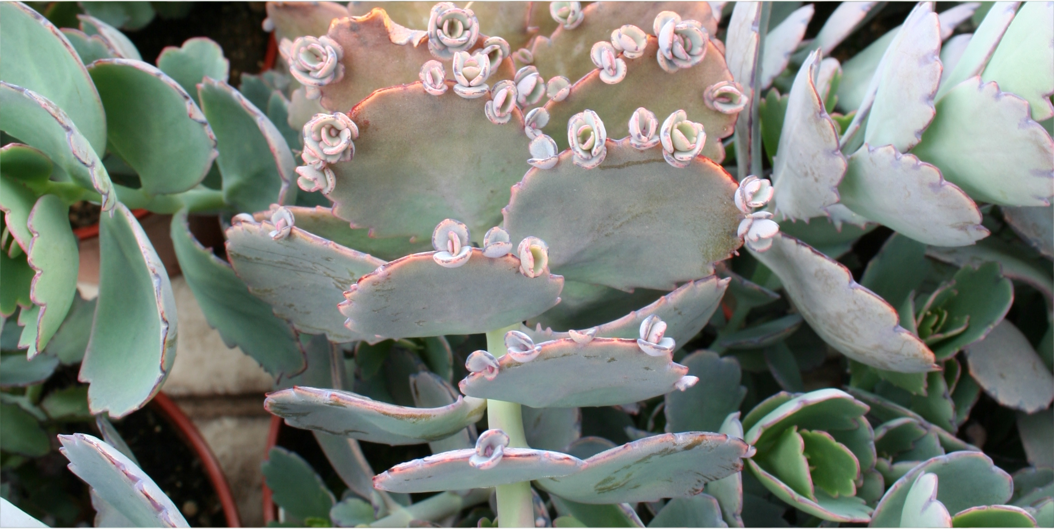

**Photosynthesis in Desert Plants: It’s About Time**

Boxall et al. investigate CAM photosynthesis in *Kalanchoë fedtschenkoi* The Plant Cell (2017). <https://doi.org/10.1105/tpc.17.00301>

*By Susanna Boxall and James Hartwell*

**Background:** During photosynthesis, most plants use the enzyme Rubisco to capture CO2 during the day. Crassulacean acid metabolism (CAM) plants such as prickly pears, pineapples, and agaves use a more efficient enzyme, phosphoenolpyruvate carboxylase (PEPC), to capture CO2 at night, and re-release the CO2 inside the leaf after sunrise. This allows them to close their stomata and thus conserve water during the hottest, driest part of day. We know relatively little about how CAM plants separate CO2 capture between day and night. One key element, however, involves the PEPC regulator PPCK, which is made each night and helps PEPC to optimize CO2 capture.

**Question:** We wanted to know if PPCK would be a necessary component of engineering other plants to use CAM photosynthesis. We tested this by switching the gene off in the CAM plant from Madagascar *Kalanchoë fedtschenkoi* (Lavender Scallops).

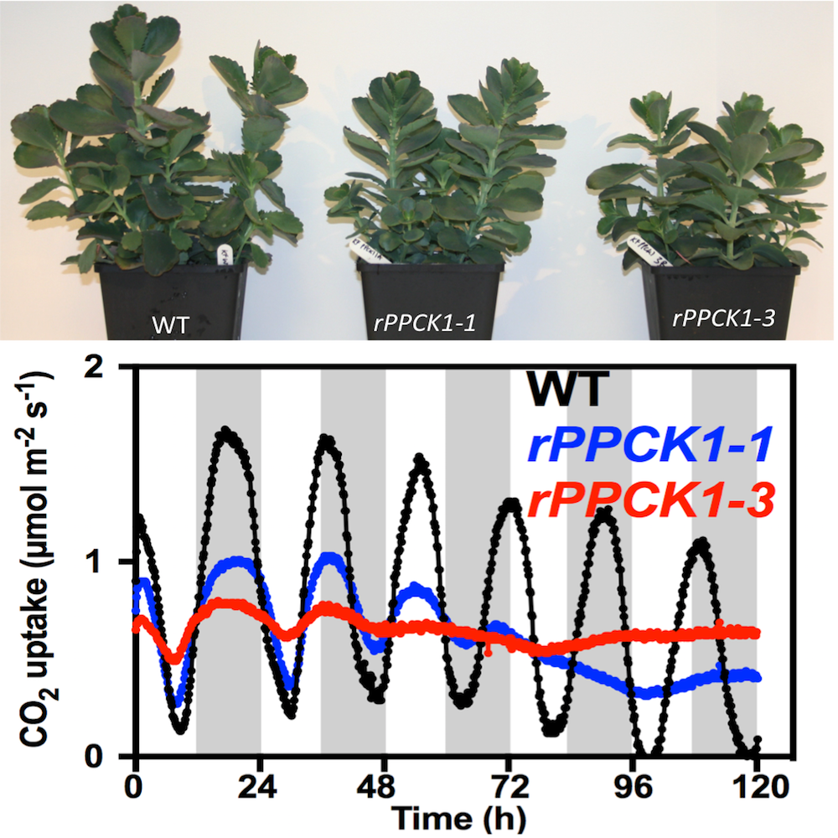

*PPCK mutants (blue and red lines) are unable to regulate CO2 uptake with a circadian rhythm.*

**Findings:** We found that, for CAM to work properly, the cells must switch on PPCK each night. When we prevented Kalanchoë from making PPCK at night, the plants could only capture a third of the CO2 captured by normal wild type plants. In addition, we discovered that plants that were unable to make PPCK each night had alterations in their internal cellular timekeeping mechanism, the circadian clock. In CAM plants, the circadian clock optimizes CO2 fixation and PPCK is one of the key ways that the cellular clock communicates time signals to control the CAM process. What was surprising was that switching off PPCK led to changes in the circadian clock itself.

**Next steps:** Scientists aim to tweak crop plants to use the CAM system to produce new crops that are better suited to growth on drought-prone lands. Our work demonstrates that ongoing efforts to engineer CAM photosynthesis into other plants will need to introduce PPCK to protect PEPC from inhibition. With PPCK working the night shift, CAM works three times better, which should help crop scientists to make the most of this amazingly water-wise form of photosynthesis.

**Susanna F. Boxall, Louisa V. Dever, Jana Knerova, Peter D. Gould and James Hartwell.** (2017). Phosphorylation of Phosphoenolpyruvate Carboxylase is Essential for Maximal and Sustained Dark CO2 Fixation and Core Circadian Clock Operation in the Obligate Crassulacean Acid Metabolism Species Kalanchoë fedtschenkoi. <https://doi.org/10.1105/tpc.17.00301>

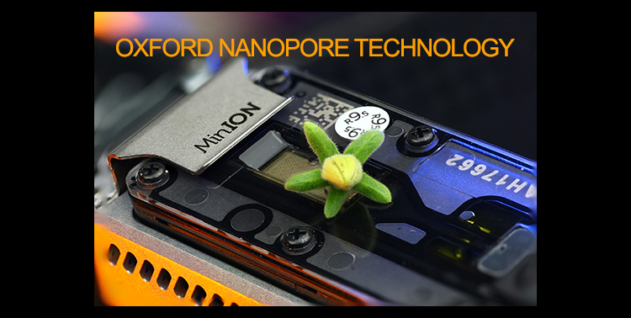

**Tomato Genome Goes Nano**

Schmidt et al. demonstrate that nanopore technology can be applied to plant genomes. The Plant Cell (2017). <https://doi.org/10.1105/tpc.17.00521>

*By M. H.-W. Schmidt, A. Vogel, A.K. Denton, A.M. Bolger, M.E. Bolger, and B Usadel*

**Background:** An organism’s genome contains all the necessary information for its existence. Every genome consists of chromosomes, made of long DNA molecules built from four bases: adenine, guanine, cytosine and thymine. The genome of the wild tomato *Solanum pennellii* consists of 12 chromosomes totalling more than 1 billion bases. Oxford Nanopore Technology translates the changes in ion flow caused by the different bases in DNA fragments threaded through tiny pores about one nanometer in diameter directly into the corresponding DNA sequence in almost real time. To read the sequence of bases in the genome, we broke the chromosomes into pieces of several thousand bases, and these fragments were “read” using nanopore technology. Finally, a program finds overlaps in the different sequences and connects them to recreate the full chromosomal sequences.

**Question:** We wanted to test if complex genomes like that of a plant could be sequenced using nanopore technology. Before this, only less complicated genomes, mainly from fungi or bacteria had been sequenced with nanopores.

**Findings:** We found that it is possible to sequence complex plant genomes using nanopores. Furthermore, nanopore sequencing makes it possible to do this relatively cheaply (about $25,000) with a relatively small working group (just 3 people in the lab) in relatively short time (about 8 months). Such a project typically would have taken several years and involved many large working groups. Unlike other sequencing technologies, nanopore sequencing furthermore does not require a big capital investment for the sequencing device itself, as the Nanopore sequencer costs only about $1000 in comparison to other sequencers that often cost more than $100,000.

**Next steps:** We are working on increasing the lengths of the DNA fragments that are sequenced from about 12 kilobases bases to 30 or even 50 kilobases. Longer fragments would simplify reading the genome and will enable reading genomes of plants which are even larger than that of the tomato genome.

**Schmidt, et al.** (2017). De novo Assembly of a New Solanum pennellii Accession Using Nanopore Sequencing. Plant Cell DOI: <https://doi.org/10.1105/tpc.17.00521>